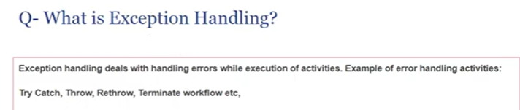

--------------------------------------------------------------------------------------------------------------------------------------

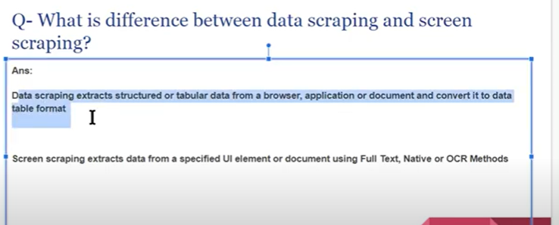

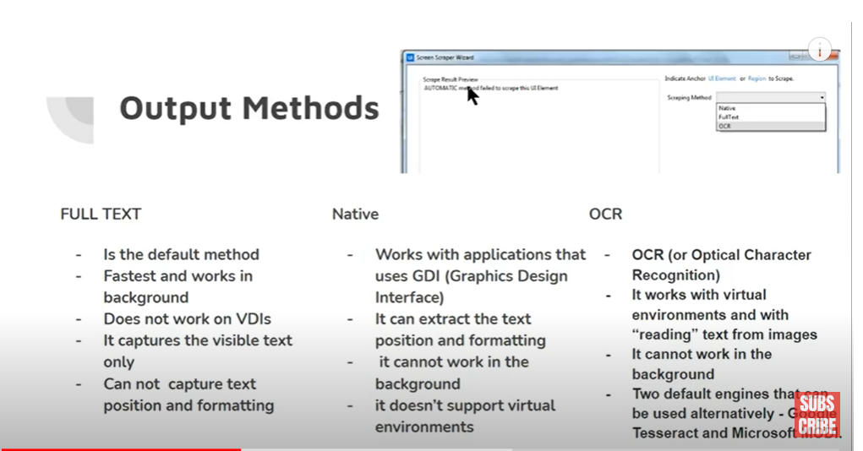

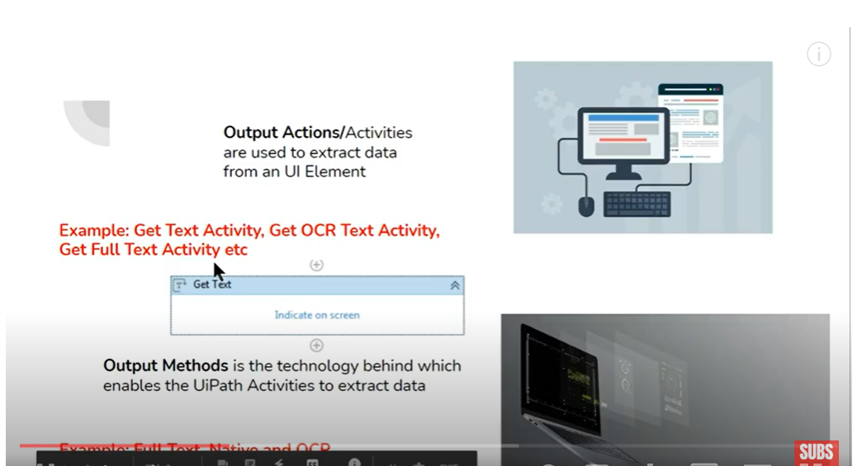

Input Methods:

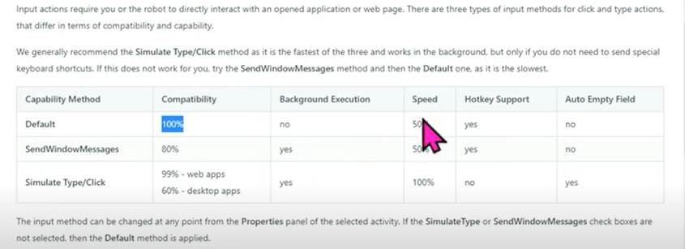

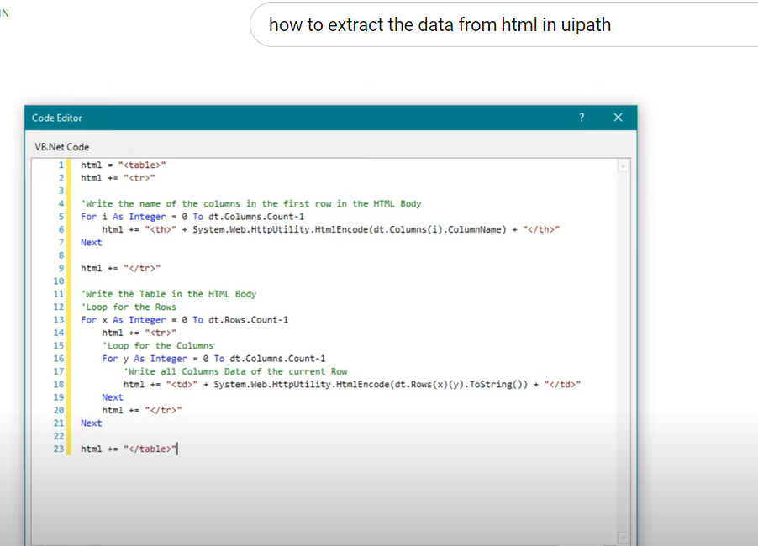

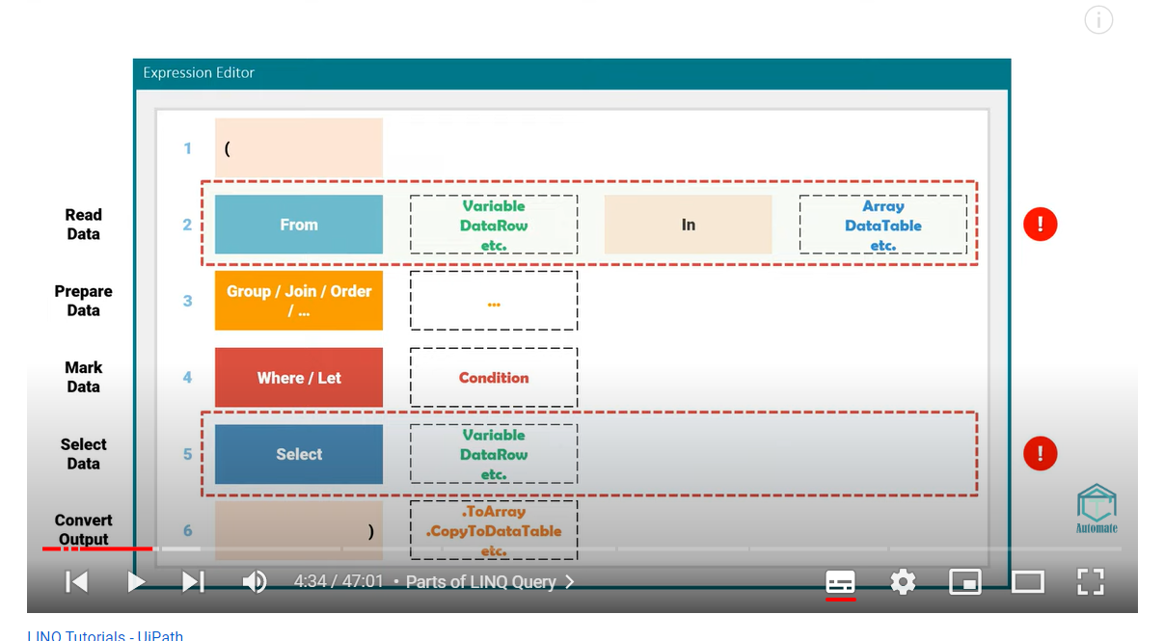

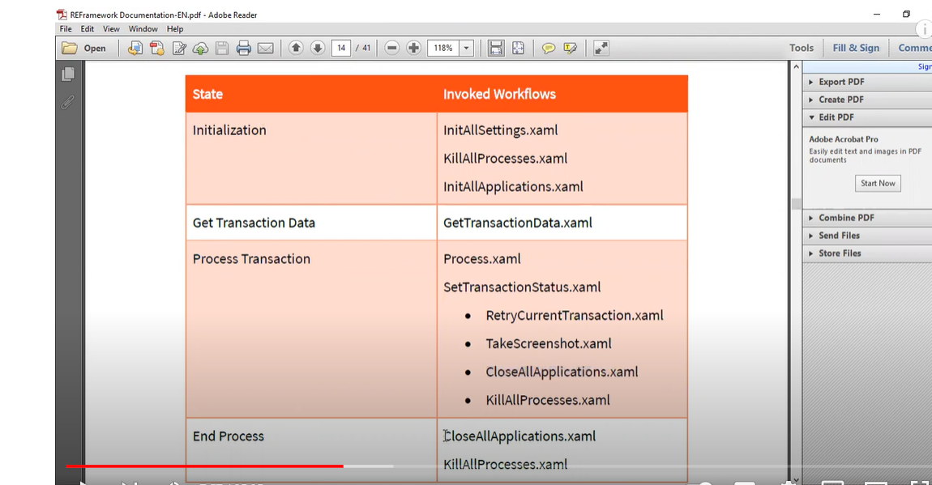

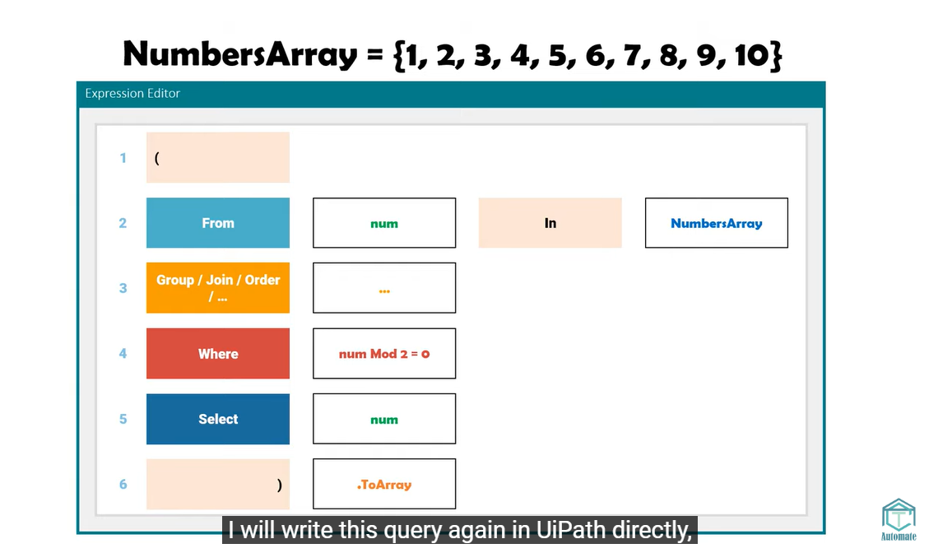

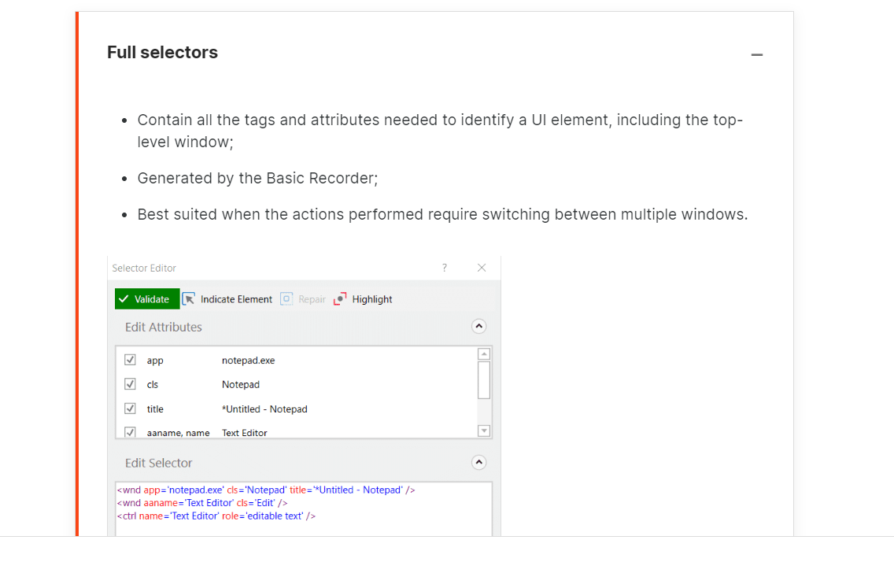

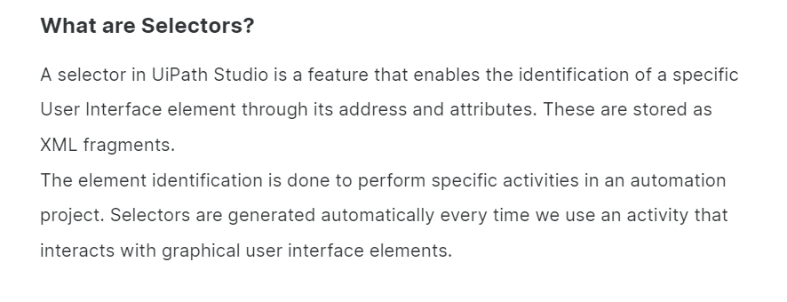

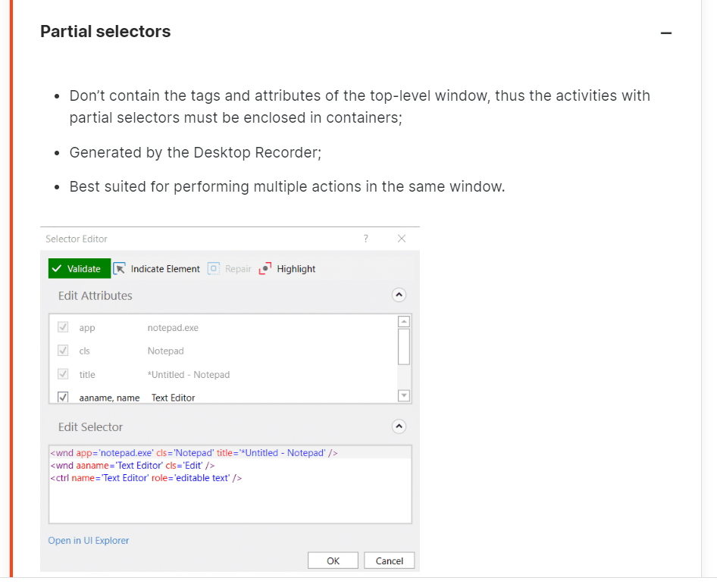

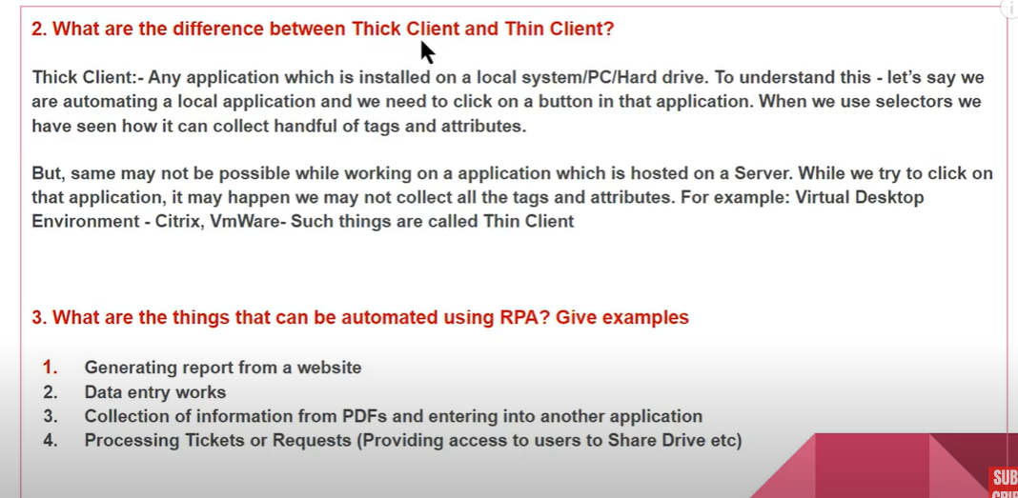

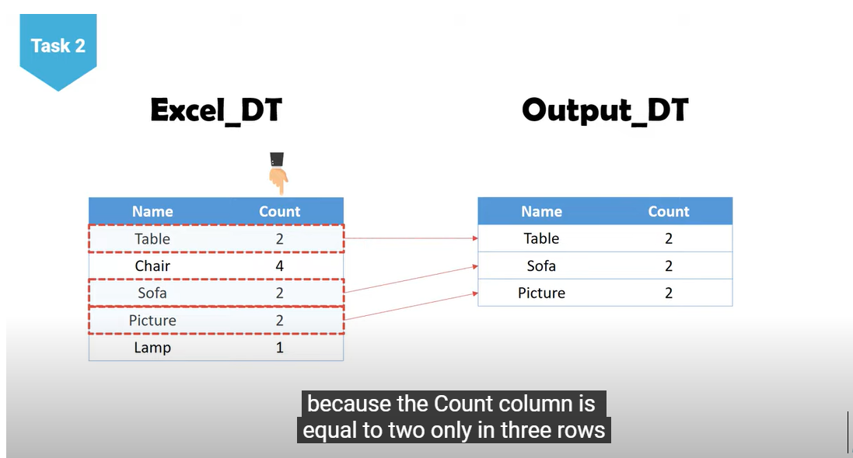

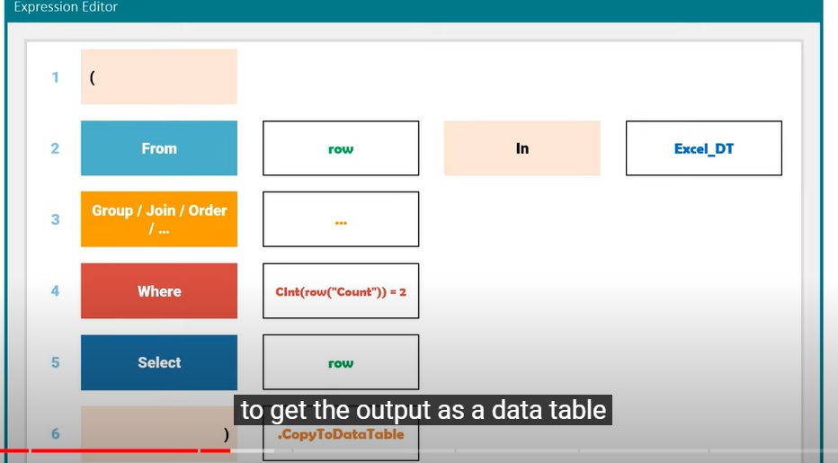

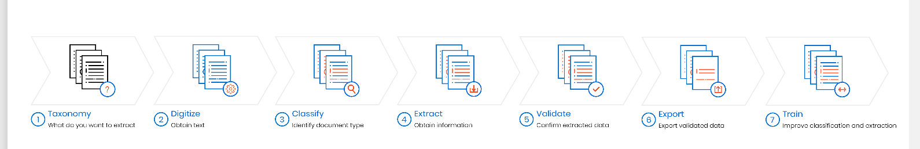

* Modern experience - The [App/Web](https://docs.uipath.com/activities/docs/app-web-recorder) and [Computer Vision](https://docs.uipath.com/activities/docs/computer-vision-recorder)recorders are available.
* Classic experience - The [Basic, Desktop, Web, Image, Native Citrix](https://docs.uipath.com/studio/docs/about-recording-types), and [Computer Vision](https://docs.uipath.com/activities/docs/computer-vision-recorder) recorders are available.
* Modern experience - The **Table Extraction** wizard is available for data scraping.
* Classic experience - The **Data Scraping** and **Screen Scraping** wizards are available.

